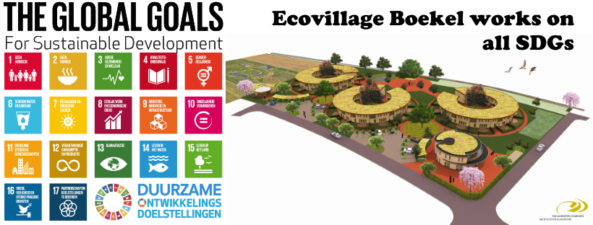

|  |
| --- |
|  |
| Research and process document  Nikita Andrianov, Luuk Geraats, Nguyen, Kate Popova, Aleksander Sopiqoti, Danial Zarei, and Taurius Antanevicius |
| |  |  |  | | --- | --- | --- | | project | 6/14/20 | ADS-A | |

# Abstract

In the abstract, you will read a high-level summary of the research that was done for eco-village Boekel.

## Rational & goal

The main goal of this research was to show the importance of the eco-village Boekel. This was done by choosing the most related and important SDG’s to eco-village Boekel (in our opinion) and show what will happen if we do nothing, of we do something and if so what we can do contribute on short notice to this SDG. The rationale behind this goal/research is to make people more aware by showing them the danger of what will happen if we (not all people) keep continuing living like this.

## Approach

Our way of working was effectively dividing work amongst group members and afterward combine the work into one document/poster/research. Within the research, the project team used a research framework named Development Oriented Triangulation Framework (DOT-framework). This framework helps you to structure the research and to communicate about it. This framework consists of 5 strategies and every strategy has a few methods on how to do research. (http://ictresearchmethods.nl/, 2018)

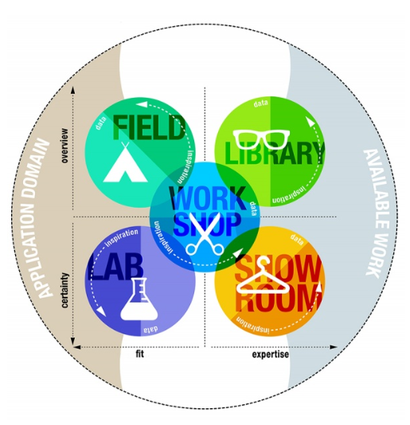

Figure 1 DOT-framework Strategies (http://ictresearchmethods.nl/, 2018)

In the table below the research methods, the project team used are mentioned.

For a more detailed explanation of the methods you can have a look at this website: <https://www.cmdmethods.nl/>

|  |  |
| --- | --- |
| Strategy | The methods used on the project |
| Library | Literature Study  Expert interview  Best, good & bad practices (cmdmethods, n.d.) |
| Field | Interview (cmdmethods, n.d.) |
| Lab | Online analytics (cmdmethods, n.d.) |

All used data sources have been described in the different chapters where the project team described the results per Sustainable Development Goal. This way you can also easily see which sources have been used per SDG.

## Storyline

The research poster below summarizes the story the project team is trying to tell and shows the urgency of eco-village Boekel and the fact that we really must do something about these SDG’s.

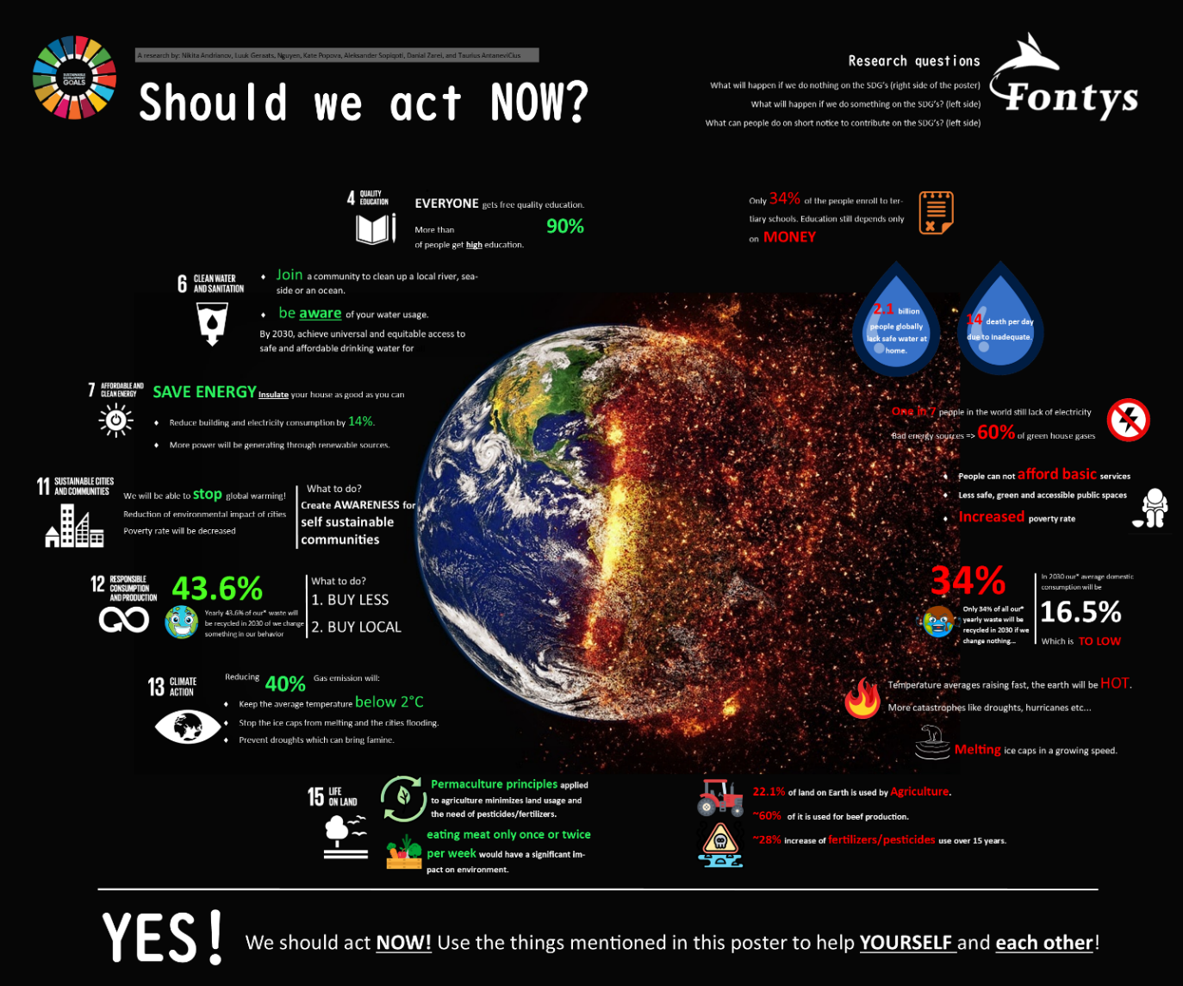

Figure 1 Research poster

Based on this poster (which includes this research) you can say there is really an urgency to act now and change our behavior now. In several SDG’s you can really say that we can reach a specific number/percentage if we do something but the goal we can reach can also be in a statement or text. The story that we want to tell with this research is the impact that we are leaving right now on the earth (right side of the poster) and the positive impact which we can reach in a few years when we do something (left side). In order to motivate people, it is also mentioned what people can do themselves (by the SDG’s where that is possible). By creating this complete story from what will happen, what can happen, and what to do we believe people will get the urgency of the eco-village and the SDG’s.

The most remarkable finding from this research is the fact that how bad we are doing right now although you do not feel the impact of that right now. However small things people can do such as buy local, buy less, or be more aware of sustainability can and do make a difference although we do also not feel the impact from that right now we will in the upcoming years if we do so.

## Recommendation

The recommendation for eco-village Boekel is easy. Keep doing what you are doing, and you will contribute to all the green numbers/statements on the left side of the poser. This research poster can be used in your educational center/website where people can also see the urgency of an eco-village and sustainable development goals. This poster can also help as ‘marketing’ in order to enthuse people for possibly joining the eco-village (in Boekel). Or this poster can be used as an eye-opener for people (who are not aware of the eco-village) and make them change their behavior in order to reach the ‘green’ numbers as mentioned in the poster.

Most important recommendation: Inspire, move, and create urgency by people who are not aware of the impact. This poster can be used as a tool for doing that.

## Concluding remarks

This research could be further extended by doing more research on what people can do themselves and make clearer the specific impact will be if someone decides to change. Regarding the research on what will happen if we do nothing and what will happen if we do something: you can keep doing research on these two factors and you will keep finding new results and interesting findings. So, our advice is to keep doing this! This will keep this research up to date. Coming with new facts or updates on the current research will make the point only stronger and more reliable. This can also be a motivating factor for people to change their behavior and reach the ‘green’ numbers.

Contents

Abstract 1

Introduction 5

1. Final product 6

2. Quality Education 7

3. Clean water and sanitation 10

4. Affordable and clean energy 13

5. Sustainable cities and communities 16

6. Responsible consumption and production 18

7. Climate action 23

8. Life on land 26

Recommendation 31

References 32

# Introduction

In this document, you will read about the process and results from the research group ADS-B group A did for ecovillage Boekel. In the abstract, you can read in a few pages the summary and most important notes of this research. In chapter one you can see and read the final deliverable, a research poster, that was made for ecovillage Boekel.

Every Sustainable Development Goal that was worked on during this research has an own (sub)chapter where the *visualizations*, *datasets* used, *scripts and code*, and a *process report* have been described by the individual student who did research on this development goal. Everything has been described in the research poster and the abstract but if you need any further detailed visualizations you can have a look there.

A short recap on original research plan: For every SDG that is in our opinion important to the world and eco-village Boekel we will do research on what will happen if we (the people) do nothing, what will happen if we do something and how we can do something. By doing that we can show the negative impact if we do nothing and the positive impact if we are getting more sustainable. We are working on the following SDG’s:

* Quality education
  + Equal access to affordable technical, vocational and higher education
  + Education for sustainable development and global citizenship
* Clean water and sanitation
  + Safe and affordable drinking water
  + Increase water use efficiency and ensure freshwater supplies
* Affordable and clean energy
  + Universal access to modern energy
  + Increase the global percentage of renewable energy
* Sustainable cities and communities
  + Safe and affordable housing
  + Reduce the environmental impacts of cities
* Life on Land
  + Conserve and restore terrestrial and freshwater ecosystems
  + End deforestation and restore degraded forests
* Responsible consumption and production
  + Sustainable management and use of natural resources
  + Remove market distortions that encourage wasteful consumption
* Climate action
  + Strengthen resilience and adaptive capacity to climate-related disasters
  + Build knowledge and capacity to meet climate change

These SDG’s have been chosen with two of their sub-goals because we believe that we can make a good story about these SDG’s and that these are the SGD’s people can do something about on short notice or need to be more aware of. A good story is important to convince the people of the urgency of the eco-village Boekel and the SDG’s.

# Final product

The final product that was created for this project is a research poster. In this research poster, all the important results from the research have been mentioned. For a better view of the research, the poster clicks [this](https://imgur.com/a/wkD2MH0) link. You can also zoom in if you want a closer look.

On the left side of the poster you see what will happen if we do something about the chosen SDG’s and by some SDG’s it is mentioned what you can do about them. The SDG’s can be easily recognized by their logo and the fact that the left side is the side that shows what will happen when we do something is because of all the green numbers and the left side of the earth is still green. On the right side, it shows what will happen if we do nothing. This can also be easily recognized by all the red (=bad) numbers and the fact that the right side of the earth is on fire.

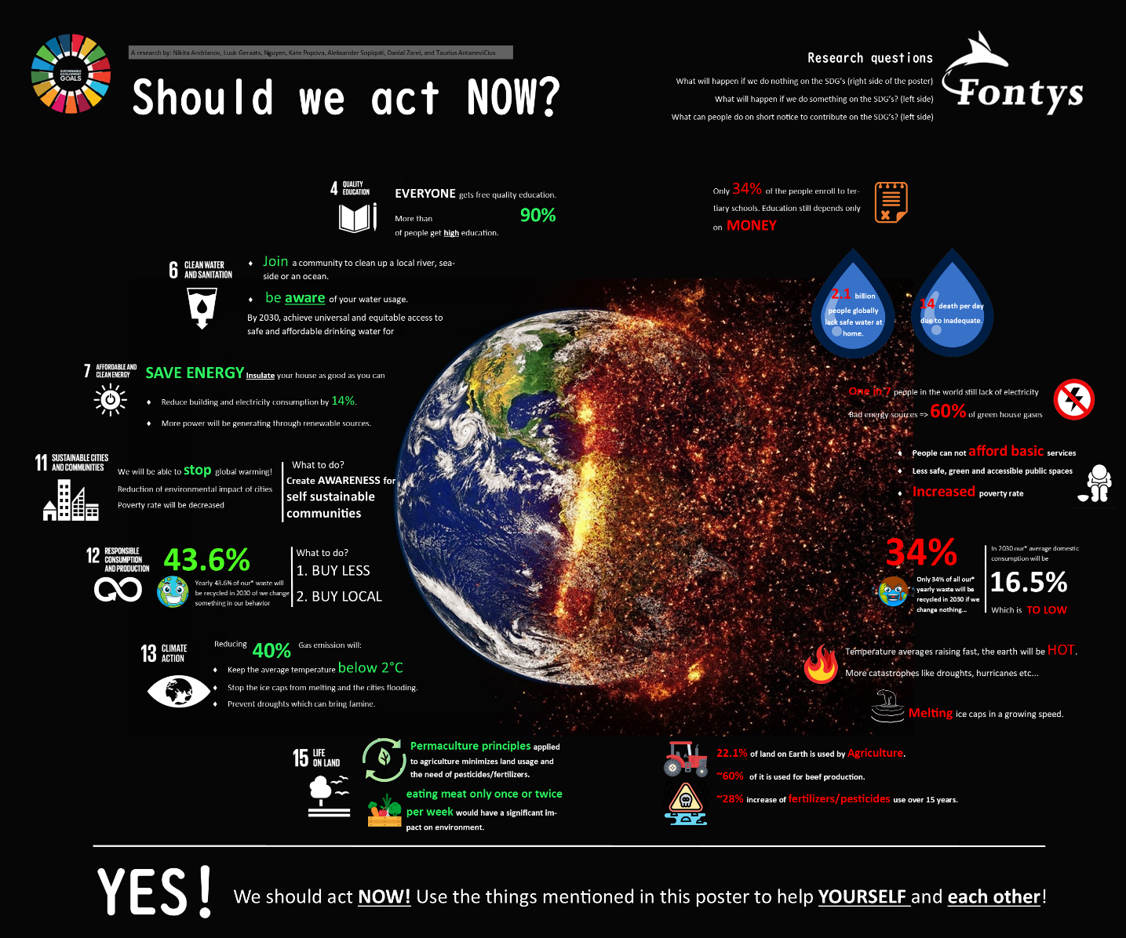

Figure 2 Research poster

# Quality Education

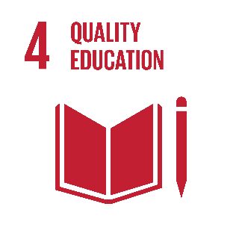Everything starts with education. To live better we need to learn more. For instance, let’s take a look at all the SDGs – they all depend on education in some way. Countries with a stable and strong economy are more likely to have a good education system and visa-versa (SDG 1). Developing countries do not invest in education or/and ecology, they do not think it is useful.

With this research our team tried to show how is the situation now and what can we expect in the future.

## Visualizations

It is hard to combine all the graphs and datasets in one dashboard or website page. A lot of topics are discussed, however not all of them are really related. We leave here the graphs and an explanation for them.

|  |  |
| --- | --- |
| [Line graph]  Changes in the amount of literate population in the world |  |
| Primary School Enrollment |  |
| [Line Graph]  Share of the population with no formal education from 1970 to 2050 |  |

In this first Graph (Changes of Amount of literate population in the world) we have a simple dataset with just a few entities like a year, amount of literate and illiterate population (everything else is not important). The graph is showing the amount of literature population in the world and how it changed. By looking at the trend line we can see that in the future we can expect only growth. There are a few drop points, that could have been caused by the wars at that time.

The second Graph (primary school enrollment):

We decided to create an interactive map with a quite large dataset. Despite it is large it is still simple, so it is easy to understand, and without any codes. We are just showing how many people were enrolled in primary schools in the past and now.

All the graphs are interactive so you can use the play button to see the progress over time!

The third graph is made to predict what will happen if we do nothing and the things will go the way they usually do. This graph shows how many people had, have, or will have no education in different countries. It is still not satisfying, because most countries still will not be able to get to a decent education (South Africa won’t reach even 20% mark!). This is a projection by IIASA.

## Datasets used

Our main data source was this website:

<https://ourworldindata.org/global-education>

We also used this website to find some insights, but did not build any graphs for the project with it:

<https://data.world/worldbank/education-statistics>

You might think that one data source is not enough for that project and so did we, but on this website, we found more than 5 datasets we could use for the project.

Datasets are big enough to see trendlines, and not hard to understand. The team used the following datasets:

“primary-enrollment-selected-countries.csv” and “literate-and-illiterate-world-population.csv”.

## Scripts and code

|  |  |
| --- | --- |
| [Line graph]  Changes in the amount of literate population in the world |  |
| |  | | --- | | Primary School Enrollment | |  |
| |  | | --- | | [Line Graph]  Share of the population with no formal education from 1970 to 2050 | |  |

## Process report

[Kate]

This was the hardest research for me. Ever.

To start with a dataset, I thought that I will find something quickly, I just googled “Quality Education Dataset”. There were a lot of platforms asking for money and were the ones that had messed up data. Among them, I found the only dataset I could with some information, however, it still was not much. And then, I decided to go to my data source link again looking for some references to data (who knows), and under on graph, I found a link to the data source.

I also needed to decide how I am going to do my project: using Python or Tableau? I just started learning data visualization with Python and it seemed easy, however, the whole group was working in Tableau, so I decided Tableau it is.

And I started the research. The graphs I made are above, and what is interesting, that while working with data I noticed some small correlations I did not see before. It was already late to add them, but I see the room for future research. For example, I was surprised to understand, that countries with communism in the past did not develop their education that much comparing to countries with capitalism. It is hard to say was that a coincidence or a real relation because everything was a secret that and we can only dream about the data back then.

# Clean water and sanitation

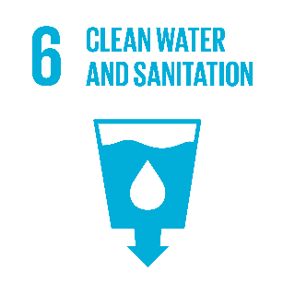This chapter is going to show you an interactive story on why water and sanitation is an important subject, and how messy things can get if we don’t invest in it properly. After the visualization, you can find the resources of the data sets being used in my visualization. In the script and code section, you can see the process of creating this project, and lastly an overview and conclusion on my report.

## What can we do?

* Organize a cleanup project for rivers and oceans. Engage your whole community to clean up a local river, seaside, or an ocean.

· Find a Goal 6 charity you want to support. Any donation, big or small, can make a difference! See <https://www.globalgoals.org/6-clean-water-and-sanitation/organisations>

· **Don't overuse water**. Make sure to close a tap when washing dishes, take short showers - Bathtubs require gallons more water than a **5-10-minute** shower. Consider getting a water meter to be aware of your water usage.

## Visualizations

Here you can find the link to my online Tableau where you can find an interactive dashboard concerning SDG *Clean water and sanitation.* [Link to the story on tableau](https://eu-west-1a.online.tableau.com/t/danialzarei/views/WaterAndSanitation/Story1/d.zarei@student.fontys.nl/b1a73a1b-aeb7-4408-8cea-33090e326922?:display_count=n&:showVizHome=n&:origin=viz_share_link)

## Datasets used

Here you can see the resources where the data sets have been extracted to build this project.

-<https://www.who.int/water_sanitation_health/monitoring/coverage/wastewater-country-files/en/>

-<https://data.unicef.org/wp-content/uploads/2017/07/WASH-data-tables.xlsx>

[-https://data.unicef.org/wp-content/uploads/2017/07/Estimates-on-water-sanitation-hygiene-waste-management-and-environmental-cleaning-in-health-care-facilities-by-country-2016_final.xlsx](http://-https://data.unicef.org/wp-content/uploads/2017/07/Estimates-on-water-sanitation-hygiene-waste-management-and-environmental-cleaning-in-health-care-facilities-by-country-2016_final.xlsx)

## Scripts and code

Here you can see the screenshots of the progress on creating this worksheet.

|  |  |
| --- | --- |
| A selection of how some of the sheets are made |  |
| Combining the datasets and their connection along with their dataset in result |  |
| Fields created |  |

## Process report

[Danial]

To get a better grasp on my research subject, I watched a few Ted talks on water and sanitation or any subjects around them, this got me intrigued and more interested to get to work. But understanding the dilemmas and issues is only part of my work. I had to learn how to project this and make my audience aware of the problem and possibly give them a good understanding of what will happen if we do something and what if we don’t. To make this happen, I had to advance my tableau skills by watching more tutorials on YouTube. In my first draft, I received a few feedbacks from Ralf on how to improve certain worksheets. I took those feedbacks into consideration and improved my work.

Next, we received feedback on our group poster. Our final version has less text, more visualizations, more readable, and more creative in my opinion. Now our message is clear on what will happen if we do something and what if we don’t on each SDG goal.

# Affordable and clean energy

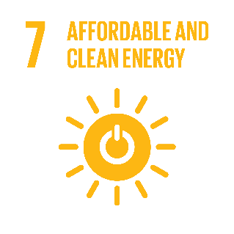

One of our biggest global problems is the demand for affordable and clean energy in many countries. Our goal is to demonstrate the value of energy in the context of a story, using data visualization. We want to illustrate what repercussions we're going to face if we don't act and what we can do to tackle the crisis.

## Visualizations

The following links direct you to an online Tableau webpage where you can see the dashboard with visualizations that have been created for this Sustainable Development Goal.

<https://public.tableau.com/views/CO2emissionsbyenergysource/CO2EmissionsbyEnergySource?:display_count=y&publish=yes&:origin=viz_share_link>

<https://public.tableau.com/views/Tableau1_15822785644360/Dashboard1?:display_count=y&:origin=viz_share_link>

Since the CO2 emissions by using bad energy sources are increasing day by day, we should take more responsibility for our energy used every day. A small example is to stop relying on polluting and unhealthy fuels for cooking.

SAVE ENERGY! Insulate your house as well as you can.

## Datasets used

<https://public.tableau.com/profile/nguyen5342#!/vizhome/Tableau1_15822785644360/CO2perCapita>

<https://public.tableau.com/profile/nguyen5342#!/vizhome/Tableau1_15822785644360/CO2EmissionChangesOverTime>

<https://public.tableau.com/profile/nguyen5342#!/vizhome/CO2emissionsbyenergysource/CO2EmissionsbyEnergySource>

## Scripts and code

All the visualization was done through Tableau. There was or should have been no coding or script. A Tableau package can be downloaded from the shareable link given in another chapter to run the whole project on your local machine.

Below are several screenshots of the project using Tableau.

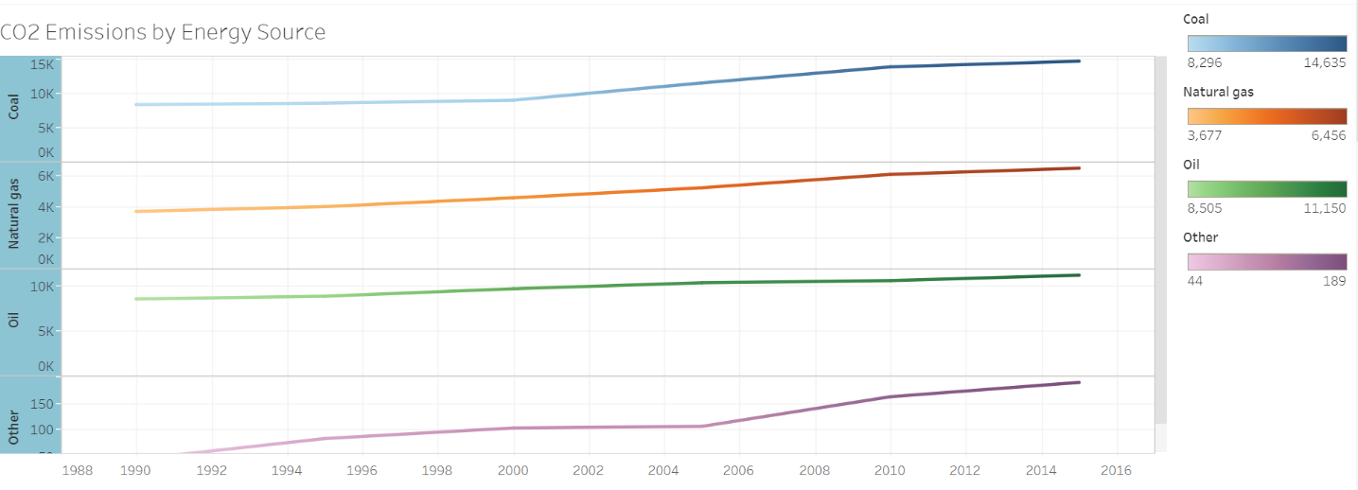

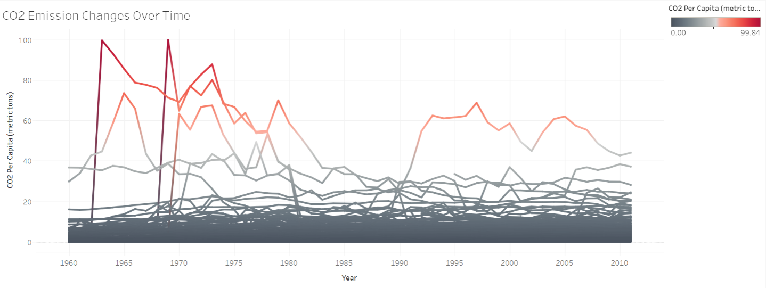

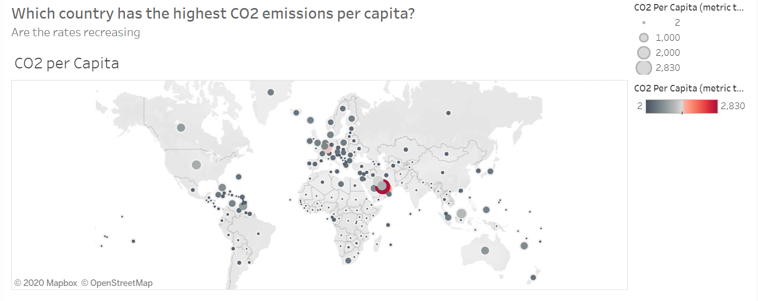

## Process report

[Nguyen]

For me, doing analysis, making the visualizations, and applying the feedback went very well. The most difficult of these was to pick and format the data to create the visualizations. I used Tableau since Tableau seemed more natural than using Python. In Tableau, graphs always look a lot better in my opinion and you have more detailed choices.

I always kept in mind that if we do nothing, and if we do something, I've had to show what happened. When making my visuals this message needs to be clear. I have done a decent job, in my view, by demonstrating what happens if we do nothing, and what happens if we do something.

I had changed a lot of things after getting feedback on the poster. I switched to the entire poster design, tried to use as little text as possible and less color than before. Comparing this poster to the first version I think the new one is much clearer when it comes to delivering messages. Simple to read and understand, and the note was made only of the major results.

# Sustainable cities and communities

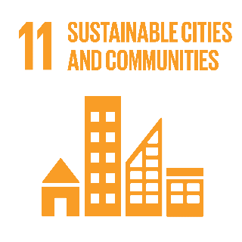In this chapter you will read about Visualization & Code, datasets used process report from the sustainable development goal sustainable cities and communities.

## Visualizations & Code

Link to the visualization and code snippets: <https://codesnippet-datascience.herokuapp.com/>

In order to run code, you need some libraries installed on Jupyter Notebook:

* Matplotlib
* Plotly
* Pandas
* Numpy

Also, you need to include all datasets as it is shown in the code section number in Notebook.

### Visualizations:

***The average annual wage in the Netherlands & Average annual wage of Netherland’s neighbors***

These graphs we have created in order to determine annual wage in the Netherlands and compare it with the annual wage of the Netherlands' neighbors such as Austria, Belgium, France, and Germany.

***Housing price index in Netherlands and Housing price index of Netherland’s neighbors***

These graphs we have created to find out the housing price index in the Netherlands and compare it with the housing price index of Netherlands' neighbors such as Austria, Belgium, France, and Germany.

***CO2 emissions worldwide 2014 & CO2 emissions Netherlands year 2000 vs the year 2014***

These graphs we have created in order to figure CO2 emissions worldwide and determine if CO2 emission has been increased and for how much in the Netherlands from the year 2000 to 2014.

**Analysis:**

* Affordable price is a critical and decisive factor. As Ecovillage Boekel is moving towards sustainability, it is important for them to have reasonable prices in the region.
* After gathering some data on the house's rent prices in the Netherlands, we noticed that for the past 5 years it has been increasing every year.
* Comparing the housing price index with countries, which are located nearby Netherland, we can see that the Netherlands has the largest housing price index.
* After analyzing all data, we can sum up that the housing pricing index and average annual salary will continue to grow. Only one factor can make a huge impact on it – COVID 19. Until one point, due to decease demand for housing can rapidly decrease, as a lot of people leave home countries leaving a lot of empty apartments.
* Nevertheless, the Netherlands has the highest average annual wage, among its neighbors. the average income in the Netherlands nowadays is over 45k annually. Considering, that in the Netherlands the price for houses in the ecovillages varies from 670 euro up to 800 + one times 5000-euro investment, I can assume that people can afford to live in Boekel.
* As we can see from the ‘CO2 emissions worldwide 2014’ plot, the Netherlands produces less than 1 million kilotons of emission per year. That indicated that the Netherlands is trying to be as much eco-friendly as it is possible.

## Datasets used

Link to the datasets used for research: https://github.com/InWiDe/DataScience-DataSets/

## How can we do something about SDG 11

* Speak up! Ask local and national authorities to engage in initiatives that don’t harm people or the planet. You can also voice your support for the Paris Agreement and ask your country to ratify it.
* Stay informed by staying in touch with Global Goals online.
* Share the knowledge.
* Take responsible actions towards SDG

## Process report

[Nikita]

In order to successfully complete this part for the group project we performed the following steps:

* Researched a lot on the SDG number 11
* Determined what topics I want to cover for a project
* Found datasets, which could support my point
* Made basic and advanced charts using Python
* Performed advanced analysis of the graphs
* Improved graphs based on the Feedback

Based on the feedback that we received from Mr. Ralf and Mrs. Monique for the group project visualization, I decided not to process furthermore with a pie chart as it can be inconvenient. Also, we made each plot self-explaining by choosing and adding appropriate x and y-axis labels.

Based on the feedback that we received from Mr. Ralf and Mrs. Monique for the group project poster, we included less text and tried to be more accurate about what we can do in order to achieve the goal of sustainable communities.

# Responsible consumption and production

In this chapter, you will read about visualization, datasets used, scripts and code, process report from the sustainable development goal responsible consumption.

The subgoals that were chosen for this SDG were:

* Sustainable management and use of natural resources (domestic consumption target)
* Remove market distortions that encourage wasteful consumption (recycle target)

The things people can do on short notice to reach the numbers as predicted in the two dashboards are the following things:

* Buy local! When you buy more local products the changes are much higher than they are originated from domestic production/farms. This means that they need to be less import which increases the number of domestic material consumption. This is a good thing because when you do not buy imported products there will be less transportation and production which is good for CO2 emissions.
* Buy less! When you buy less, you consume less which increases the change of buying imported products. This will increase the number of domestic material consumption. Also, when buying less you contribute to the other SDG’s (for example, climate action) because less import and fewer productions mean less C02 emissions.
* Recycle more! When you recycle more products and divide your waste properly so the waste processing companies can recycle there you will increase the recycling rate. You can start by stop buying products which include plastic or start giving old waste/products a new purpose as the interior.

## Visualizations

The following links direct you to an online Tableau webpage where you can see the dashboard with visualizations that have been created for this Sustainable Development Goal. The insights that were gathered from the visualizations are also mentioned.

* [Recycle the target dashboard.](https://public.tableau.com/profile/luuk5266#!/vizhome/projectrecycledashboard/dashboardrecycle?publish=yes)

[Line Graph] Recycling rate (% of total waste) if we do nothing

* + In this line graph, you can see the recycling rate in percentage of the total municipal waste per year and per country predicted until 2030 if we change nothing in our recycling habits. For now, we only filtered on the Benelux and Germany because these are countries close to the Netherlands. This is an interactive graph so you can use the filter/slicer above the graph to see the progress over the years. (1990-2030). The years 2018-2030 are predicted based on the previous data by using the advanced analytics tool from Tableau. As you can see Germany and Luxembourg are doing pretty well and Belgium and the Netherlands falling a bit behind. Funny that you can see the negative impact of the economic crisis in 2008 in the Netherlands. If we do nothing the recycling rate will keep on decreasing Belgium and the Netherlands. Germany and Luxembourg are still fine.

[Line Graph] Recycling rate (% of total waste) if we do something

* + In this line graph, you can see the recycling rate in percentage of the total municipal waste per year and per country predicted until 2030 if we change something in our recycling habits. These predictions are based on the growth in the previous years, how the government functions, and the discipline the people in a country have. For Example: In the Netherlands people are very disciplined if the government tells them something (look at these corona times). And therefore, the growth in the rate is very high. Belgium, Germany, and Luxembourg have a smaller growth. As you can see Germany recycles over 50% of its waste and the Netherlands, Belgium and Luxembourg are having that same linear growth.

Household products you can easily recycle:

* + In this table, you can see products that most people use in their daily household which can be recycled. This can be done by reusing them, giving them another purpose (for example plant a plant and empty bottle of water instead of buying a bucket or going to a special recycle point (for example: where they recycle/reuse phones or ipads) People can look up for products and check if they use the content in their household.
* [Domestic consumption target](https://public.tableau.com/profile/luuk5266#!/vizhome/projectluukdomesticprod/dashboarddomestic?publish=yes)

[Line graph] Domestic material consumption per capita predicted

* DMC: Measures the total amount of materials directly used by an economy and is defined as the annual quantity of raw materials extracted from the domestic territory, plus all physical imports minus all physical exports. The DMC indicator provides an assessment of the absolute level of the use of resources and allows us to distinguish consumption driven by domestic demand from consumption-driven by the export market. It is important to note that the term "consumption" as used in DMC denotes apparent consumption and not final consumption. DMC does not include upstream "hidden" flows related to imports and exports of raw materials and products. (Eurostat b, 2018)
* In this graph, you see a prediction for the DMC per capita (Benelux). As you can see Luxembourg has the highest DMC value. This means that they use most domestic materials for their own purposes. They do not export/import that much as for example the Netherlands. Based on the data that is available Tableau made the prediction that the DMC value of Luxembourg will increase, and Belgium will stay the same and Germany and the Netherlands will decrease. This means that Luxembourg will be going to use more domestic materials and that the Netherlands and Germany are going to import/export more.

[Line Graph] Domestic material consumption per capita predicted if we something:

* In this graph, I predicted the DMC is we change something in our daily behavior. We predict that all DMC values for the Benelux will decrease. This means that we are going to import/export more and use fewer domestic materials. This could be considered as good and bad. Bad because there is more transportation which means more trucks/planes/boats/trains that need to travel. But is contributes positively to the economy of the Benelux. The decreases are small because we believe that more and more people are trying to grow own vegetables and buy local products (domestic) but these numbers do not add up against the big companies who are importing and exporting.

## Datasets used

Datasets and sources used:

* <https://stats.oecd.org/Index.aspx?DataSetCode=MUNW>
* <https://unstats.un.org/sdgs/indicators/database/>
* <https://ourworldindata.org/plastic-pollution>

## Scripts and code

Since the visualization for this Sustainable development goal has been made in Tableau there is not really a script/code for recreating the visuals. What can be shown is how the different dimensions and measures have been set up. A sample of the data that has been used is also attached.

|  |  |
| --- | --- |
| Graph | Settings |
| [Line graph] Domestic material consumption per capita predicted |  |
| [Line Graph] Domestic material consumption per capita predicted if we something |  |
| [Line Graph] Recycling rate (% of total waste) if we do nothing |  |
| [Line Graph] Recycling rate (% of total waste) if we do something |  |

## Process report

[Luuk]

Doing research, making the visualizations, and applying the feedback went actually really well for me. The most challenging was to chose and format the data in order to make the visualizations. I used Tableau because If felt more comfortable by Tableau then by using Python. Also, in my opinion graphs look way better in Tableau and you have more options regarding details. I always kept in mind that I had to show what happened if we do nothing and what will happen if we do something. This message needs to be clear while making my visuals. In my opinion, I have done a good job by showing what will happen if we do nothing and what will happen if we do something. After I finished my first draft the only feedback, I got was that there may be something wrong with the data since Luxembourg has such a high domestic consumption while the other three countries do not. There was nothing wrong with the data, Luxembourg has just a high domestic consumption ratio. Thus, I changed nothing after receiving feedback on the visuals.

After receiving feedback on the poster, I did change a lot of things. I changed to the whole design for the poster, tried to use as little text as possible, and only mention the major results. Comparing this poster to the first version I think the new one is much clearer in his message. Easy to read and understand and only the mayor results have been mentioned.

# Climate action

As the Co2 particles in the atmosphere rise fast, so does the global annual temperature. This is known as the ‘greenhouse effect’ and it can bring catastrophically phenomena like long droughts, melting ice caps which can flood a lot of big cities, less quality in the air we breathe and so much more. To combat this, 185 countries around the world have signed the Paris Agreement and pledged to make a change and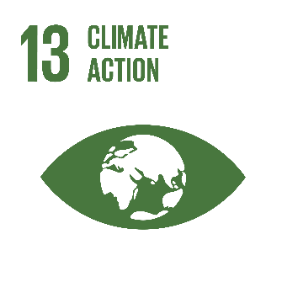 keep the global temperatures below 2 degrees Celsius. Usually, GHG emission is caused mostly by big companies and the government has the upper hand in acting by using regulations. What we can do, is stay informed about the climate, make small changes ourselves (recycling, use EV cars, etc.) and not keep silent about this issue.

## Visualizations

The visualization was done using Tableau Story. Every chart, graph, a map is put together in a ‘Story’ with the explanations, overviews, and conclusion that can be drawn from them.

[Click this sentence to redirect to the website.](https://public.tableau.com/shared/BJWHC8XWD?:display_count=y&:origin=viz_share_link)

During the visualization, some abbreviations and some concepts are used which needs further explanation to fully understand:

* GHG – greenhouse gases (mainly consisting of C02, N2O, CH4). In this presentation, the measures are only for CO2.
* Target Year – The year in which the ‘pledges’ of each country need to be completed or have significant improvements towards the pledges.
* Base Year – The year in which the current progression will be based on. For example, if a pledge says: ‘reduce CO2 by 30% in 2030’, the measures in 2030 will be compared to the measures in the base year (1990) and see if they are really 30% less.
* Lowess – refers to ‘Locally Weighted Scatterplot Smoothing’, sometimes called LOESS and it’s a popular tool used in regression analysis that creates a smooth line through a timeplot or scatter plot to help you to see a relationship between variables and foresee trends. In this case, it is used to smooth global mean temperatures.

P.S: The pledges are pre-2020, the 2020 pledges are still in the making, as Coronavirus affected every country. There are theories that say Corona had a positive impact on the atmosphere.

## Datasets used

1. Ed Dlugokencky and Pieter Tans, NOAA/ESRL ([*www.esrl.noaa.gov/gmd/ccgg/trends/*](http://www.esrl.noaa.gov/gmd/ccgg/trends/))
2. For the Global Mean Temperatures: NASA <https://data.giss.nasa.gov/gistemp/graphs/graph_data/Global_Mean_Estimates_based_on_Land_and_Ocean_Data/graph.txt>
3. WRI, CAIT Climate Data Explorer. 2015. Washington, DC: World Resources Institute. Available online at <http://cait.wri.org>
4. WRI, CAIT Climate Data Explorer. 2016. CAIT Paris Contributions Map. Washington, DC: World Resources Institute. Available at: http://cait.wri.org/indcs/

All the datasets were commented inside the respective file. The only data cleanup was for the first two. They were just text files (not CSV nor excel files) so I had to copy-paste the data to excel sheets. From there it was easy to create tables from the files to Tableau. The only connection between datasets was between the first two datasets (they were connected by the attribute ‘Year’).

## Scripts and code

All the visualizations were done using Tableau. No coding or script was or should be used. To run the whole project on your local machine a Tableau package can be downloaded from the shareable link mentioned in chapter 7.1. Since the data is extracted you do not need to download it.

Some snapshots of the visualization can be seen below:

|  |  |
| --- | --- |
| A showcase of using two datasets and links between them (Year). |  |
| Creating a dashboard using a sheet and a text canvas. Those dashboards can be put on a Story. |  |
| Using a new type of chart known as ‘pie chart’ to show how much only two countries contribute to GHG. |  |
| The use of a map containing all the countries and their pollution of CO2. A color gradient was used in red (to underline the fact that it is not positive) to better see the countries with high C02 pollution. |  |

## Process report

[Aleksander]

From experience, doing a lot of research is an integral part of starting a project. Having good knowledge from the start makes the implementation easier. First, it was hard because I did not have much knowledge about this subject. What strikes me the most is that every article or information about Climate Action was based around the ‘Greenhouse gases’, mostly CO2, and that’s true. An increase in GHG, has bought increasing temperatures, which as we know are not good for the Earth.

Another important aspect is the ‘Action’. After we learn about the Climate and what is happening with it, taking realistic steps is important. The Paris Agreement was the most well-known, global plan for climate action, with each country setting its goals.

The one thing I regret was missing out on receiving feedback from my teachers. But using the other's work and feedback and constantly asking for help or keep track of the project helped me to finish my part. Also, I wish I would not be analyzing a lot of different aspects of Climate Action, as it is better to take one aspect and try to examine it as best as possible.

# Life on land

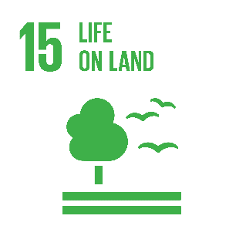

## Visualizations



## Datasets used

FAO – Food and Agriculture Organization of the United Nations datasets:

Land Use - <http://www.fao.org/faostat/en/#data/RL>

Pesticides Use - <http://www.fao.org/faostat/en/#data/EP>

Fertilizers Use - <http://www.fao.org/faostat/en/#data/EF>

## Scripts and code

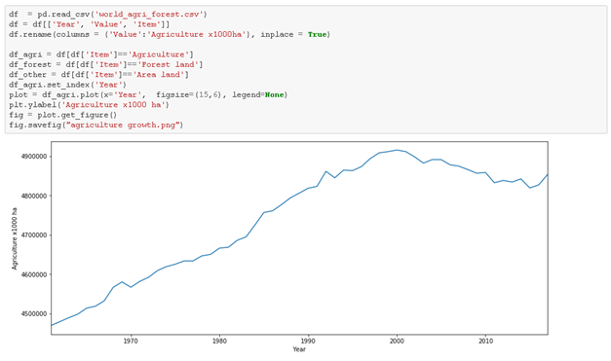

For this timeline chart, we used the “Land Use” dataset from FAO. To make them value more presentable, we renamed it from “Value” to “Agriculture x1000ha”. With the help of pandas, we did the manipulation of data and made a chart.

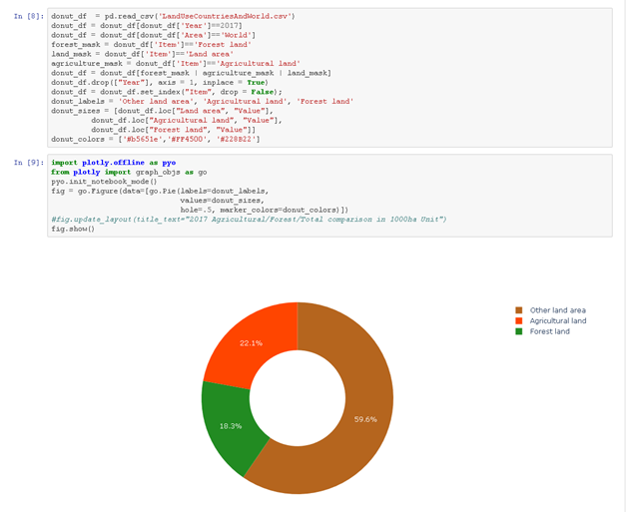

For this donut chart, we used the Plotly .ofline framework that makes the graph nicely interactive and easy to plot. In order to process data from a large dataset, we scoped it down to be only 2017, World Area, and 3 types of interest that are shown in the chart. Then we selected the colors that in my opinion match the represented names and with the help of plotly made a pie chart with the hole inside of it, so it looks like a donut chart.

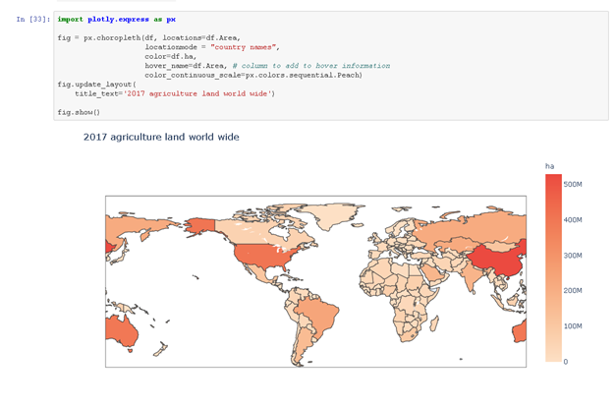

We found another framework called Plotly.express that is appropriate to make map charts either of the world or of the states of America. Since we were interested in the whole world, we passed the country names from the FAO dataset to the function, together with the variable of interest that is total agriculture land and Plotly made an interactive choropleth map chart by displaying each country and the corresponding value to it upon hover.

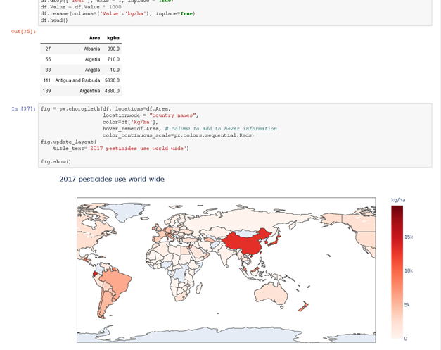

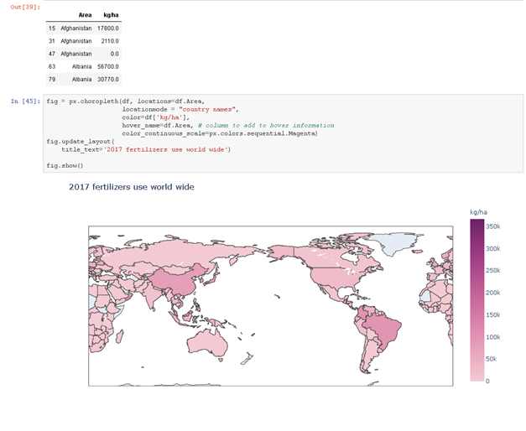

Since we were interested in how agriculture affects life on land SDG, we passed different values to plotly choropleth function in order to display the distribution of pesticides and fertilizer distribution.

## Process report

One of the biggest existing problems of Life on Land SDG is unsustainable agriculture that has various damage to the environment. Besides, the underground water pollution, soil erosion, and other problems agriculture take up a significant amount of land on Earth. The trends show that it will not get better if we do nothing, but rather worse. Therefore, farmers that work on agriculture should take collective action to change the way they do agriculture. What is good that permaculture principles that could be used by farmers not only would be friendly to the environment but also would let farmers held higher yields, therefore, there does not have to be a sacrifice there, however, a change is required. On the other hand, for consumers who have nothing to do with agriculture could adjust the way they consume. The meat consumption that has the most impact on the environment when producing can be significantly reduced if we choose to eat less meat.

After the feedback from Mr. Ralf and Mrs. Monique, we chose to use different frameworks in order to make the maps clearer and more interactive. Instead of using geopandas, we started to use Plotly and had great results. The maps are interactive: they show values of countries upon hover and are zoomable. As well as, legends were added since it was missing in the first version. In addition, more details were fixed that were missing like labels of axes, also improved the display of quantity – instead of x1000ha, we decided to display just ha and have M for million or K for thousand in order to increase readability and user-friendliness.

Finally, we had the advice to avoid pie charts in order to minimize confusion, however, instead of changing all of it, we implemented it as a donut-chart, added percentages to each part of it in order for people to easily estimate the accurate part of a certain area. Furthermore, the donut chart starts from “12’o clock” now that is a proper way to display it, however, in the first version the placement was rather randomized.

In conclusion, to improve the current situation of life on land SDG the advice to farmers would be to try to adapt different agriculture principles that would be more beneficial to both the environment and farmers (permaculture principles, e.g.) and the advice for the consumers is to limit the meat consumption to 1-2 times a week in order to contribute to making the meat consumption demand lower, since the production is the most resource-demanding, as well as, the most negatively impacting the environment.

# Recommendation

The recommendation for eco-village Boekel is easy. Keep doing what you are doing, and you will contribute to all the green numbers/statements on the left side of the poser. This research poster can be used in your educational center/website where people can also see the urgency of an eco-village and sustainable development goals. This poster can also help as ‘marketing’ in order to enthuse people for possibly joining the eco-village (in Boekel). Or this poster can be used as an eye-opener for people (who are not aware of the eco-village) and make them change their behavior in order to reach the ‘green’ numbers as mentioned in the poster.

Most important recommendation: Inspire, move, and create urgency by people who are not aware of the impact. This poster can be used as a tool for doing that.

# References

Sustainable Development Goal specific references/sources can be seen in the specific chapter.

cmdmethods. (n.d.). CMD Methods Pack - find a combination of research methods that suit your needs. Retrieved March 10, 2020, from <https://www.cmdmethods.nl/>

Eurostat b. (2018, December 13). Domestic material consumption - Knowledge for policy European Commission. Retrieved May 15, 2020, from <https://ec.europa.eu/knowledge4policy/glossary/domestic-material-consumption_en>